Name of Laboratory : Basic Electrical Engineering Lab

|  |  |
| --- | --- |
| Lab Subject Code | : EEE101L |
| Name of School | : SELECT |
|  | |
| **MEASUREMENT OF ELECTRICAL POWER AND ENERGY** | |
| **Ex. No. : 8** | **Date: 6/12/2021** |
| **Aim** |  |

To measure the power and energy consumed by a single-phase load.

**Materials Required**

|  |  |  |  |
| --- | --- | --- | --- |
| **S. No.** | **Name of the Apparatus** | **Range / Type** | **Quantity** |
|  |  |  |  |
| 1 | Ammeter | ( 0 – 10 A ) MI | 1 No. |
|  |  |  |  |
| 2 | Voltmeter | ( 0 – 300 V ) MI | 1 No. |
|  |  |  |  |
| 3 | Wattmeter | 300 V, 10 A, UPF | 1 No. |
|  |  |  |  |
| 4 | Energy meter | 1-phase, digital | 1 No. |
|  |  |  |  |
| 5 | Resistive load | 5 kW | 1 No. |
|  |  |  |  |
| 6 | Stop clock | ----- | 1 No. |
|  |  |  |  |
| 7 | Wires | 1 sq. mm” | As required |
|  |  |  |  |

**Theory**

The watt-hour meter is an instrument used for measuring energy. As energy is the product of power and time; the watt-hour meter must take into consideration both of these factors. Induction type of energy meters are universally used for measurement of energy in domestic and industrial AC circuits. The term testing includes the checking of the actual registration of the meter as well as the adjustments done to bring the errors of the meters within the prescribed limits.

Direct loading method is similar to the one explained in the calibration of wattmeter. Here a standard wattmeter is used for comparing the values. When the capacity of a meter under test is high, a test with the ordinary loading arrangements would involve a considerable waste of power. To avoid this “phantom or fictitious” loading arrangements are employed. These consist in supplying the pressure circuit from a circuit of the required normal voltage, and the current circuit from a separate low voltage supply. This means that the total power supplied for the test is that due to the small pressure coil current at normal voltage plus that due to the load current at a low voltage and the total power is therefore only a comparatively small amount.

Name of Laboratory : Basic Electrical Engineering Lab

|  |  |
| --- | --- |
| Lab Subject Code | : EEE101L |
| Name of School | : SELECT |
|  |  |

**FORMULAE USED**

1. Actual power = W x Multiplication factor Where W – Observed wattmeter eading
2. Apparent power = VI watts Where V – Voltmete reading
   * 1. I – Ammeter reading
3. Power Factor, cosØ = Actual Power / Apparent Power
4. True energy = (wattmeter reading * time ) / 60*60*1000 Kwh
5. Recorded energy = (No of Rev) / energy meter constant Kwh
6. % Energy = (recorded energy – true energy )*100 / True energy

**Procedure**

1. Collect the materials required for this experiment.
2. Make the connections as shown in circuit diagram.
3. After closing the DPST switch adjust the auto-transformer to the specified voltage of the energy meter.
4. Switch ‘ON’ some specific load. Note down Ammeter, Voltmeter and wattmeter readings. Also note down the time taken by energy meter disc to complete a specified number of revolutions using stop clock. This is repeated for different load condition.
5. True energy is calculated by multiplying the wattmeter reading and the time.
6. Recorded energy is obtained using energy meter constant and no. of revolution.
7. Result are tabulated (Refer Table) and a graph between percentage error and True energy is drawn.

**Precautions**

1. Energize the circuit with the presence of Lab instructor / Faculty.
2. Auto transformer should be in minimum voltage position.
3. All the loads should be in ‘OFF’ position.
4. No part of a live circuit should be touched by the bare hand.
5. Keep the body, or any part of it, out of the circuit.
6. Keep the work area and workbench clear of items not used in the experiment.
7. When disassembling a circuit, first remove the source of power.

Name of Laboratory : Basic Electrical Engineering Lab

|  |  |
| --- | --- |
| Lab Subject Code | : EEE101L |
| Name of School | : SELECT |
|  |  |
| **Sample Calculations** |  |

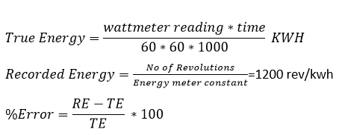

**Circuit Diagram**

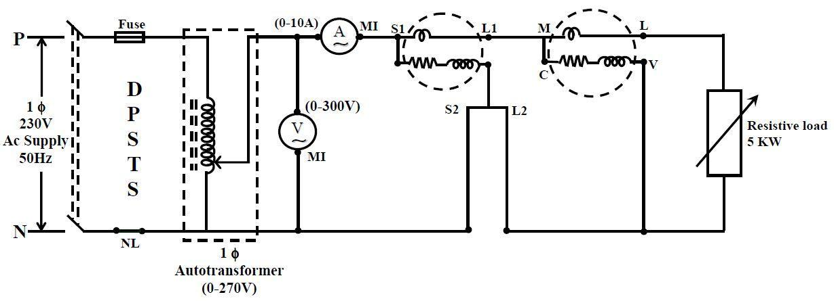

**Tabulations**

|  |  |  |  |  |  |  |  |  |  |  |
| --- | --- | --- | --- | --- | --- | --- | --- | --- | --- | --- |
|  |  | Voltmeter | Ammeter | Wattmeter | No. of | Time | Recorded | True |  |  |
|  |  | reading | reading | reading | taken by | Error |  |
| Load(W) | S. No. | revolutions | energy | energy |  |
|  | (V) | (I) | (W) | Disc (T) |  |  |
|  |  |  |  |  |  |  |
|  |  |  |  |  |  |  |  |  |  |  |
|  |  | Volts | Amps | Watts |  | Seconds | kwh | kwh | % |  |
| 250 | 1 | 230 | 0.96 | 120*2 | 5 | 64 | 0.00426 | 0.00416 | 2.4 |  |
|  |  |  |  |  |  |  |  |  |  |  |
| 500 | 2 | 230 | 1.93 | 255*2 | 5 | 30.7 | 0.00434 | 0.00416 | 4.32 |  |
|  |  |  |  |  |  |  |  |  |  |  |
| 750 | 3 | 230 | 2.7 | 350*2 | 5 | 22.4 | 0.00434 | 0.00416 | 4.32 |  |
|  |  |  |  |  |  |  |  |  |  |  |
| 1000 | 4 | 230 | 3.63 | 470*2 | 5 | 16.6 | 0.00432 | 0.00416 | 3.84 |  |
|  |  |  |  |  |  |  |  |  |  |  |
| 1250 | 5 | 230 | 4.44 | 570*2 | 5 | 13.6 | 0.00430 | 0.00416 | 3.33 |  |
|  |  |  |  |  |  |  |  |  |  |  |
|  | 6 |  |  |  |  |  |  |  |  |  |
|  |  |  |  |  |  |  |  |  |  |  |

Name of Laboratory : Basic Electrical Engineering Lab

|  |  |
| --- | --- |
| Lab Subject Code | : EEE101L |
| Name of School | : SELECT |
|  |  |

**Result**

Net Power Consumed is 416 watt.

Power factor =1

**Reg. No: 21BDS0340 Name: Abhinav Dinesh Srivatsa Date: 6/12/2021**